**SPH3U 8.1 Vibrations**

1. **Vibrations and mechanical waves**

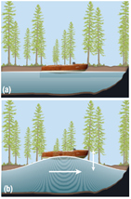

|  |  |
| --- | --- |
| Vibration: |  |
| equilibrium |  |
| Mechanical wave: |  |
| medium |  |
| net motion |  |

1. 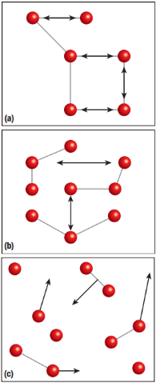**Particle behaviour in different media**

|  |  |
| --- | --- |
| Waves in solids: |  |
| elastic material |  |
| Waves in fluids: |  |

**Homework:** page 380: #1-4